

ASSIGNMENT 01:
COURSE TITLE:
DATA STRUCTURE

COURSE CODE:
SE-203

SUBMITTED TO:
MUHAMMAD SABEEH

SUBMITTED BY:
EMAN FATIMA

ROLL NUMBER:
25021598-140

SUBMISSION DATE:
15 SEPTEMBER,2026

DEPARTMENT:
SOFTWARE ENGINEERING 3RD SEMESTER

Question 1 — Array Operations
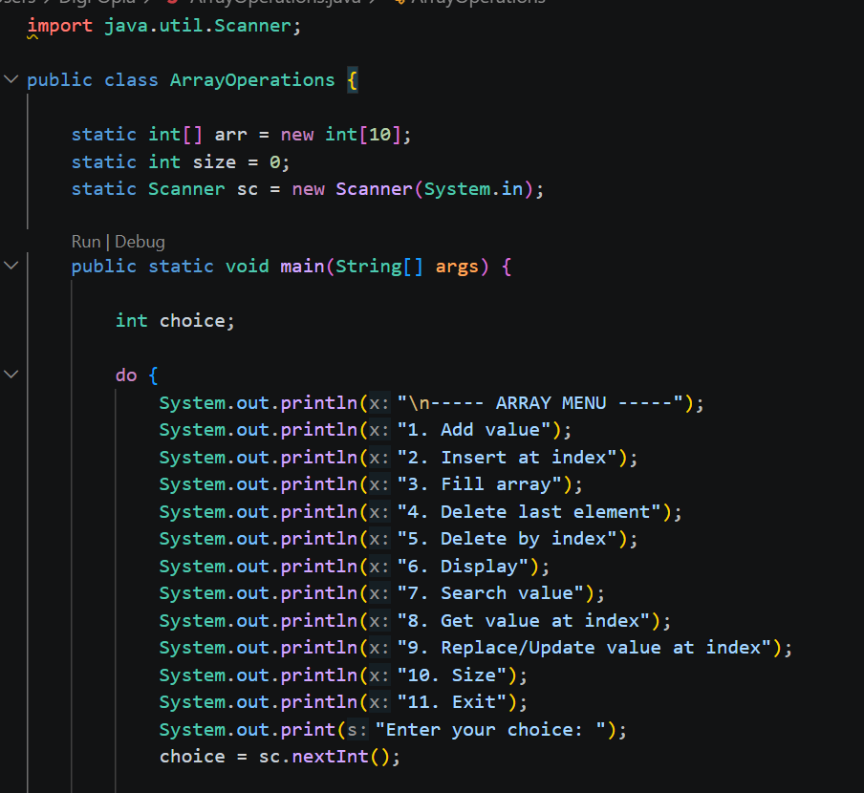
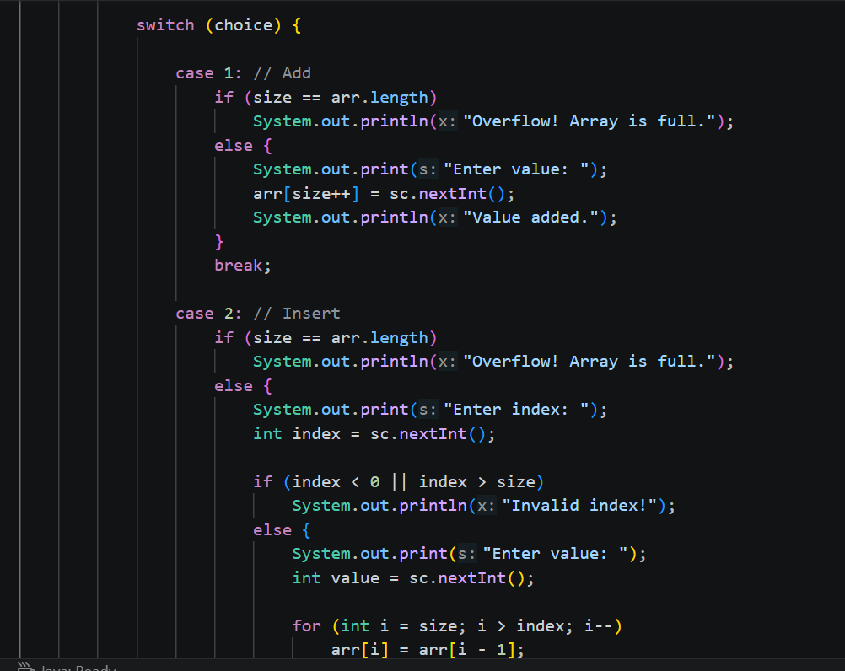

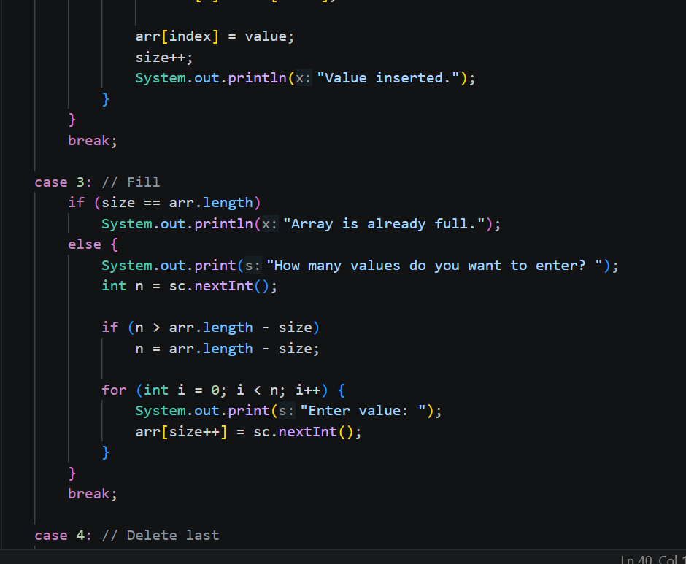
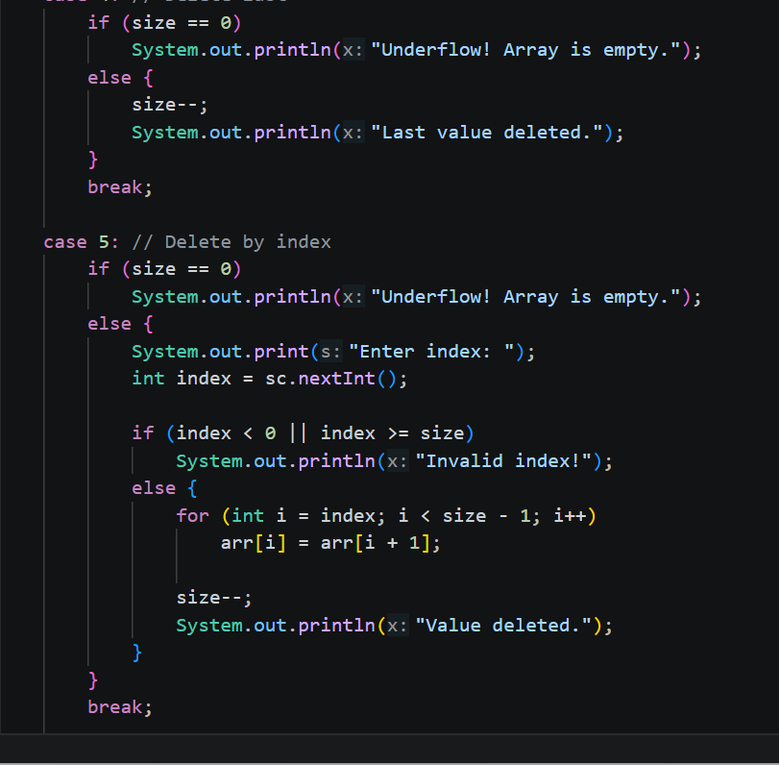

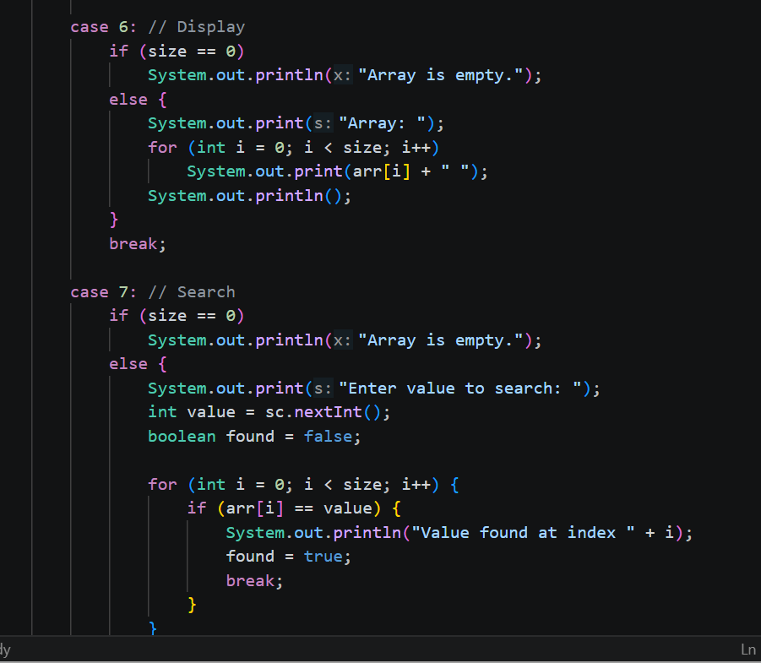
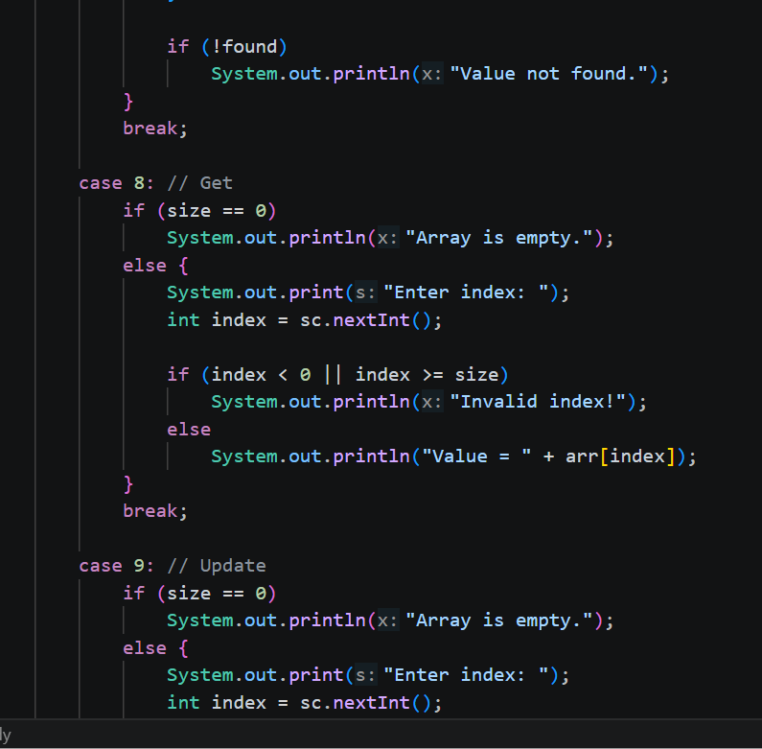
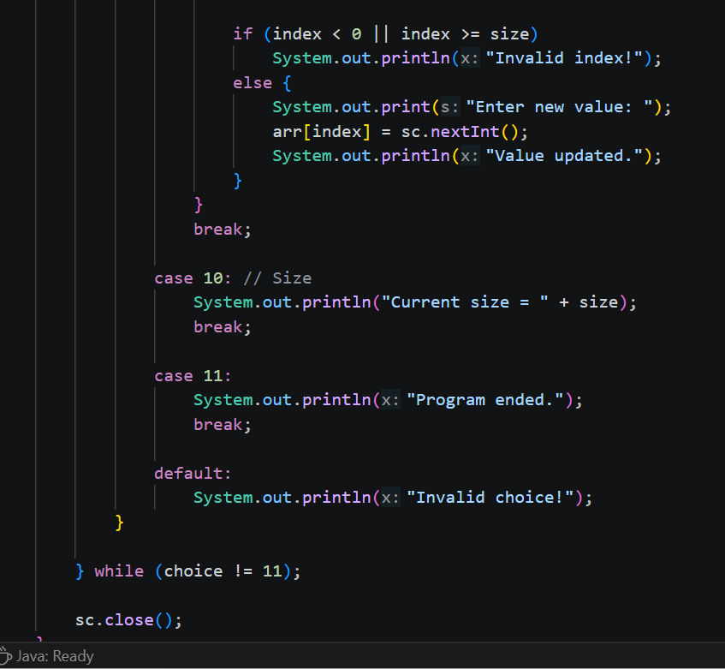
OUTPUT:
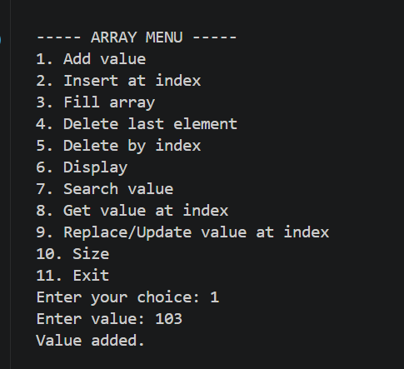

Question 2 — Stack Operations
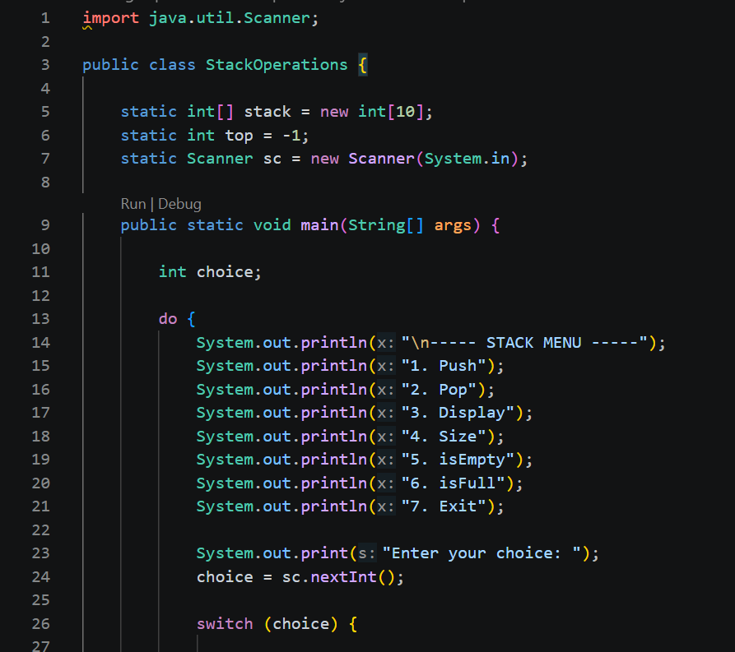
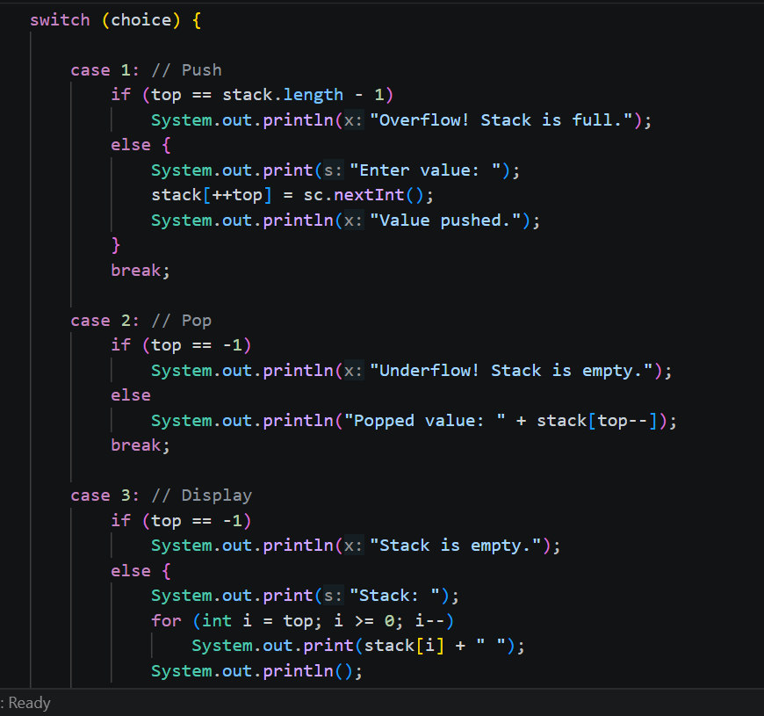
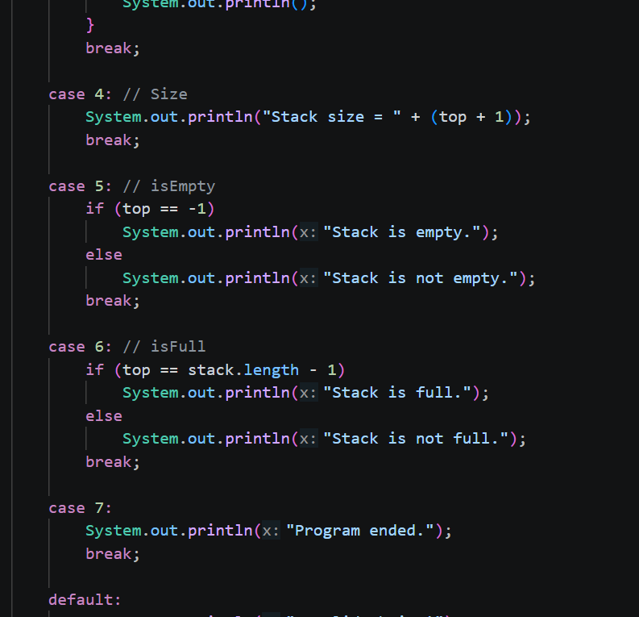
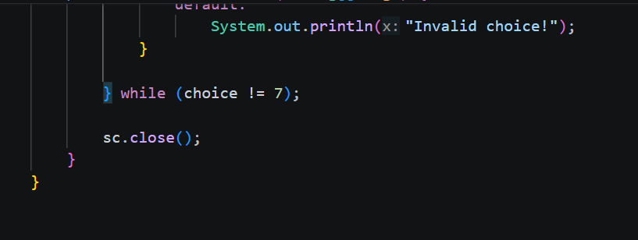

OUTPUT:

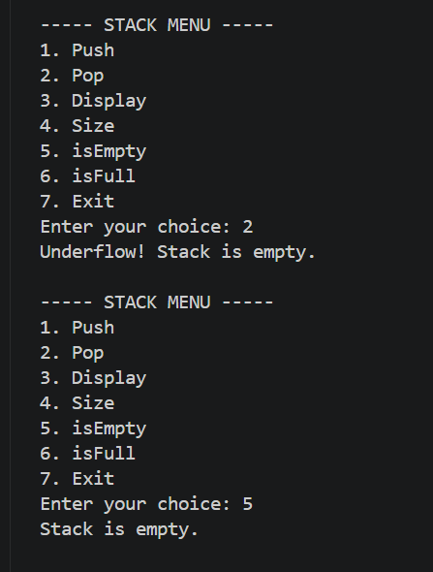

Question 3 — Queue Operations
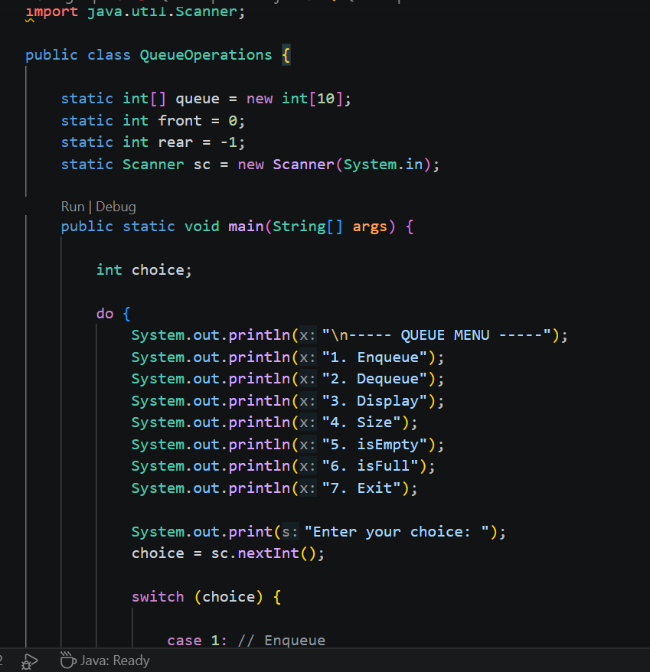
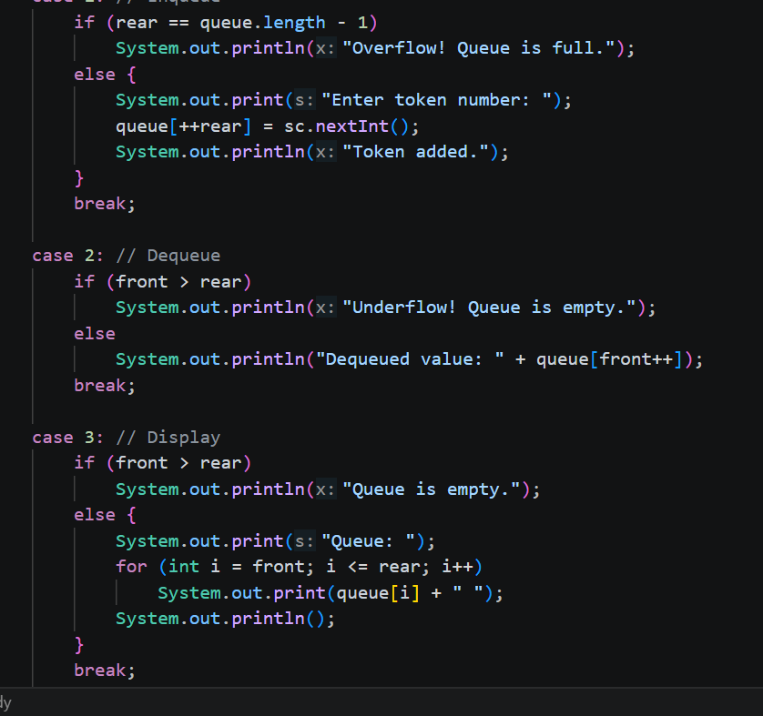

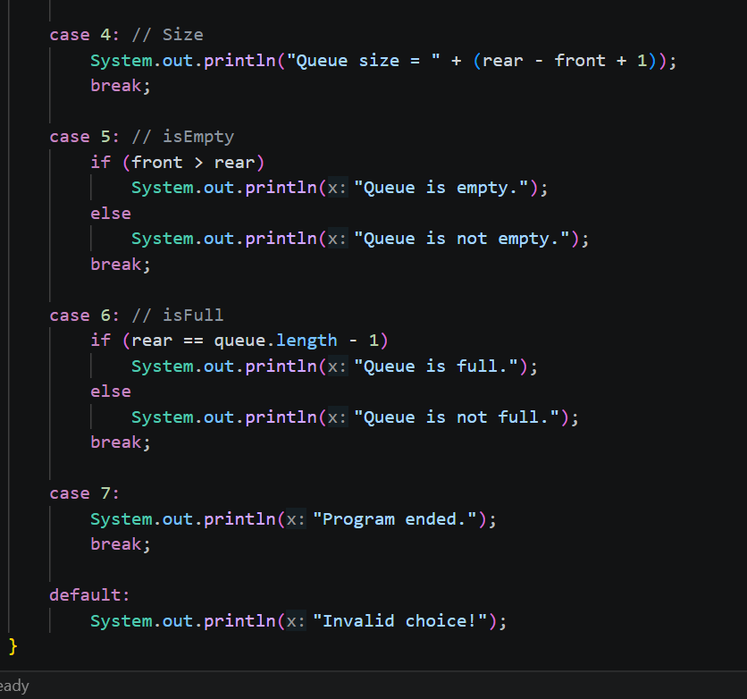
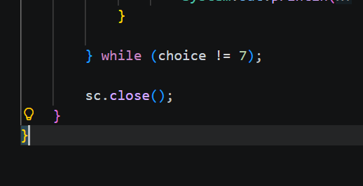

OUTPUT:
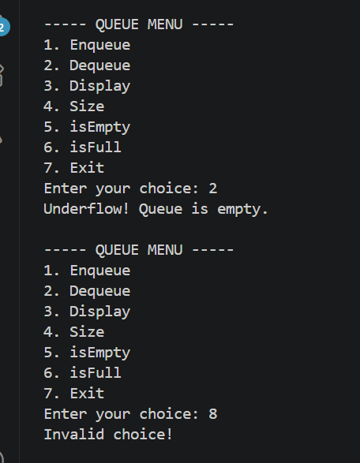

Question 4 — Real-World Examples of Data Structures
1. Array:
Example | Why Array is Suitable
Student marks | Marks can be stored in a fixed and indexed order.
Book IDs on a shelf | Book IDs can be stored and accessed using index numbers.
Monthly temperatures | A fixed number of temperature values can be stored easily.
Employee salaries | Salaries can be stored in a simple sequence for quick access.
Product prices | Prices can be stored and accessed quickly by index.
2. Stack:
Example | Why Stack is Suitable
Undo in a text editor | The latest action is undone first.
Browser Back button | The most recent page is returned first.
Function calls in programs | The last function call finishes first.
Plate stack | The last plate placed on top is removed first.
Expression evaluation | Operators and values can be processed in LIFO order.
.
3. Queue:
Example | Why Queue is Suitable
Bank customer tokens | The first customer to arrive is served first.
Printer jobs | The first print job is normally processed first.
Waiting line at a shop | Customers are served in arrival order.
CPU task scheduling | Tasks can be processed in a waiting order.
Call center requests | The earliest request can be handled first.

Contents
No table of contents entries found.
Question 5 — Advantages and Disadvantages
Advantages of Array:
- Easy to use and understand.
- Fast access using index.
- Stores data in an organized way.
- Uses memory efficiently for fixed-size data.
Disadvantages of Array:
- Fixed size.
- Insertion can be slow.
- Deletion can be slow.
- May waste memory if the array is not full.
2.Stack:
Advantages of Stack:
- Simple to implement.
- Fast push and pop operations.
- Useful for LIFO problems.
- Helps manage function calls and undo operations.
Disadvantages of Stack:
- Only the top element can be accessed easily.
- Fixed-size stack can become full.
- Searching for an element is not efficient.
- Not suitable when data must be processed in order of arrival.
3. Queue:
Advantages of Queue:
- Follows FIFO order.
- Easy to manage waiting data.
- Enqueue and dequeue are simple operations.
- Useful for scheduling and processing tasks.
Disadvantages of Queue:
- Direct access to middle elements is difficult.
- Fixed-size queue can become full.
- Searching is not efficient.
- Array-based queues may require extra logic to reuse empty spaces.

c

